RESEARCH PROPOSAL
Growth and Characterization of Two-Dimensional
Ferromagnetic Materials at Room Temperature
Enhanced figure-rich version modeled after the 2021 proposal format
Executive Summary. The proposed research targets scalable synthesis, rigorous verification, and device integration of two-dimensional ferromagnetic materials that retain long-range magnetic order at and above room temperature. The core strategy is to combine strong perpendicular magnetic anisotropy, controlled stoichiometry, defect/vacancy engineering, and clean van der Waals interfaces to produce CrTe₂, Fe₃GaTe₂, MnS₂/ReS₂, Fe₅₋xGeTe₂, and MBene-based candidate films. The deliverables include reproducible MBE/CVD protocols, a standardized multi-technique characterization workflow, and proof-of-concept anomalous Hall, magnetic tunnel junction, and spin-orbit torque devices.
I. Specific Aims
This project proposes a coordinated materials-to-device program for room-temperature two-dimensional ferromagnets. The central hypothesis is that long-range magnetic order in atomically thin films can be stabilized when magnetic anisotropy, epitaxial strain, stoichiometric control, and interface cleanliness are engineered together rather than optimized separately. The proposed work is organized into four integrated aims:
- Aim 1 — Scalable growth: establish reproducible MBE and CVD protocols for CrTe₂, Fe₃GaTe₂, MnS₂/ReS₂, Fe₅₋xGeTe₂, and vacancy-engineered MBene nanosheets with controlled thickness down to the monolayer/few-layer limit.
- Aim 2 — Intrinsic magnetism verification: create a standardized, multi-technique protocol combining STEM, XRD, RHEED, RBS, XPS, EDS, SQUID, MOKE, MFM, XMCD, ARPES, and transport measurements to distinguish intrinsic ferromagnetism from substrate, impurity, and defect-only signals.
- Aim 3 — Device demonstration: fabricate room-temperature Hall bar, magnetic tunnel junction, and spin-orbit torque devices to quantify anomalous Hall response, tunneling magnetoresistance, switching current, thermal stability, and reproducibility.
- Aim 4 — Mechanism and data integration: link growth conditions to magnetic anisotropy, Curie temperature, electronic structure, and device performance using DFT, statistical process mapping, and open-access datasets.
Deliverables and success metrics
Aim | Primary question | Key methods | Success metric
Aim 1 | Can target films be grown reproducibly at useful area? | MBE, CVD, RHEED, AFM, RBS | ≥1 cm² films; RMS roughness ≤10 nm; T_C within 10% across ≥10 runs
Aim 2 | Is the ferromagnetism intrinsic? | SQUID, MOKE, MFM, XMCD, ARPES, STEM | Consistent thickness-dependent and element-selective magnetic evidence
Aim 3 | Can films operate in devices at 300 K? | AHE, MTJ, SOT transport | AHE switching in ≥10 devices; target TMR >30% at 300 K
Aim 4 | What growth knobs control T_C and PMA? | DFT+SOC, process maps, data repository | Open dataset and predictive growth-property map
II. Background and Motivation
Atomically thin magnetic crystals have transformed condensed matter physics because they allow spin order, spin transport, band topology, strain, electrostatic gating, and proximity effects to be controlled in a single material platform. The major barrier is temperature: many early two-dimensional ferromagnets exhibit magnetic ordering only at cryogenic temperatures, whereas practical memory, logic, and sensor applications require robust operation above 300 K.
The Mermin-Wagner theorem indicates that isotropic two-dimensional Heisenberg systems cannot sustain long-range magnetic order at finite temperature because long-wavelength spin fluctuations destroy spontaneous magnetization. In real materials this restriction can be overcome when magnetic anisotropy creates a spin-wave gap. Therefore, the search for room-temperature 2D ferromagnets is fundamentally a search for materials and heterostructures with strong spin-orbit coupling, robust exchange interaction, controlled defect chemistry, and stable interfaces.
Recent progress has changed the field from a cryogenic proof-of-principle area into a materials engineering challenge. Few-layer CrTe₂ grown by MBE has shown ferromagnetism near room temperature; Fe₃GaTe₂ crystals and epitaxial films combine high Curie temperature with strong perpendicular magnetic anisotropy; template-assisted MnS₂ has provided an emerging semiconducting route; and vacancy-engineered MBenes demonstrate that deliberately created vacancies can activate room-temperature magnetic order in air-stable two-dimensional borides.
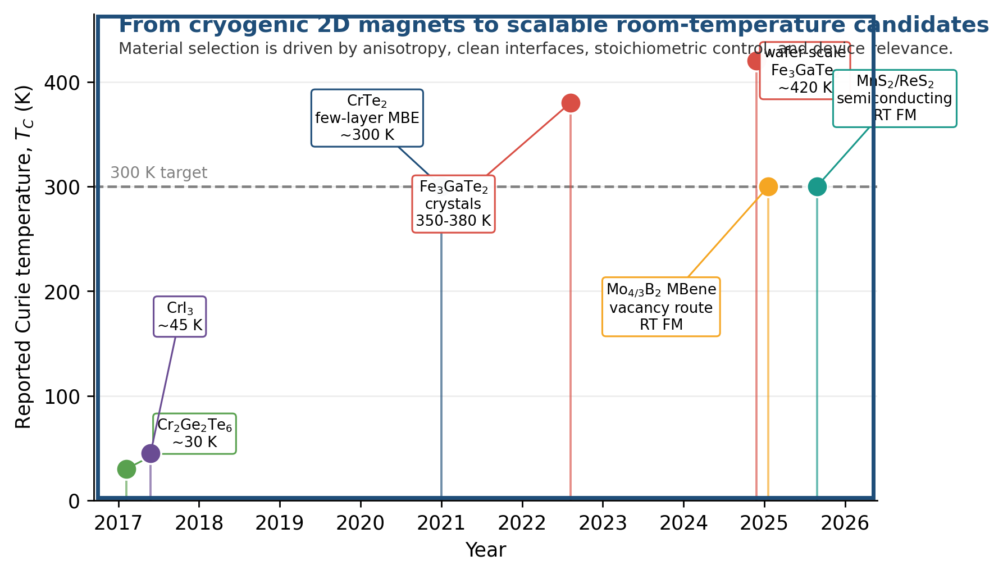
Figure 1: Roadmap from cryogenic two-dimensional ferromagnets to room-temperature candidates targeted in this proposal. The dashed line indicates the 300 K device-relevance threshold; values are approximate literature benchmarks used to guide the materials selection strategy.
Critical knowledge gaps
- Scalability: many high-performance 2D magnetic materials are still measured on exfoliated flakes or localized regions; wafer-scale synthesis with uniform stoichiometry, phase purity, and roughness remains a central challenge.
- Reproducibility: small changes in growth temperature, flux ratio, substrate termination, and post-growth exposure can produce different phases or extrinsic magnetic signals.
- Intrinsic verification: sub-nanometer films require multiple cross-checks because substrate moments, interfacial reactions, magnetic contamination, and oxidation can mimic weak ferromagnetism.
- Device integration: spin injection, tunnel barrier control, current-induced switching, and thermal stability remain insufficiently benchmarked at 300 K and above.
III. Strategy and Significance
The proposed strategy follows the logic of the 2021 proposal example: start from a scientifically important bottleneck, choose materials with complementary functions, integrate them through controllable synthesis routes, and verify performance using a direct mechanistic workflow. Here, the bottleneck is the stabilization of room-temperature ferromagnetism in atomically thin, process-compatible materials. The key design principles are summarized below.
- Strong magnetic anisotropy: heavy elements and spin-orbit coupling provide perpendicular magnetic anisotropy that suppresses thermally activated spin fluctuations.
- Itinerant exchange and high moment density: Fe-rich tellurides such as Fe₃GaTe₂ and Fe₅₋xGeTe₂ provide large magnetic moments and metallic transport for Hall and SOT devices.
- Semiconducting functionality: MnS₂/ReS₂ and related group-VI chalcogenide candidates offer a path toward magnetic semiconductors compatible with logic and optoelectronic architectures.
- Defect and vacancy control: MBenes and chalcogenides allow vacancy concentration to be treated as an intentional variable rather than an uncontrolled defect.
- Clean interfaces: h-BN, MoS₂, graphene, and topological insulator layers enable tunable tunnel barriers, spin-current generation, and protection from oxidation.
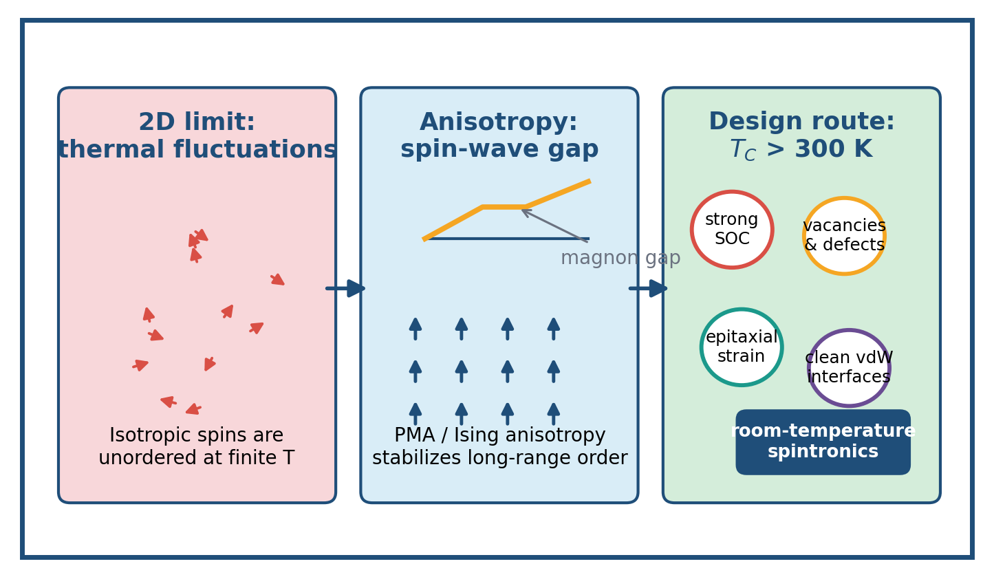
Figure 2: Design principle for stabilizing magnetism in the two-dimensional limit. Magnetic anisotropy, strain, defect control, and clean interfaces open a spin-wave gap and increase the probability of stable ferromagnetic order above room temperature.
Material platform
Material family | Reason for selection | Main growth route | Main risk | Mitigation
CrTe₂ | Benchmark MBE-grown vdW ferromagnet near room temperature | MBE on graphene/SiC and HOPG | Te volatility, phase control | Te-rich calibration and in-situ RHEED
Fe₃GaTe₂ | High T_C and large PMA; device-ready metallic ferromagnet | MBE / flux-growth benchmark | Ga/Fe stoichiometry window | RBS/XPS feedback and anneal map
MnS₂/ReS₂ | Semiconducting room-temperature candidate | Template-assisted CVD | Phase stability and domain size | ReS₂ matrix templating and rapid QD-AFM screening
Mo₄/₃B₂ MBene | Vacancy-engineered air-stable magnetism | Molten-salt etching and vacancy tuning | Vacancy reproducibility | Chemical titration + XPS/XMCD correlation
Fe₅₋xGeTe₂ | Scalable vdW ferromagnetic heterostructure candidate | vdW epitaxy on graphene | Off-stoichiometry and roughness | Flux ratio sweep and STEM verification
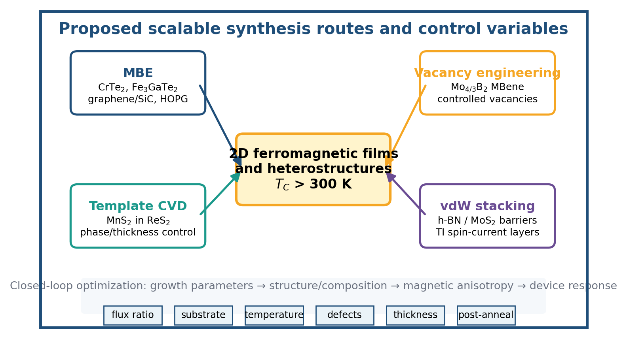
Figure 3: Proposed synthesis routes. MBE, template-assisted CVD, vacancy engineering, and van der Waals stacking are treated as complementary routes to the same target: stable 2D ferromagnetic films and heterostructures with room-temperature functionality.
IV. Research Approach
A. Molecular beam epitaxy and epitaxial benchmarks
CrTe₂ and Fe₃GaTe₂ will be grown by ultra-high-vacuum MBE on epitaxial graphene/SiC(0001), HOPG, and selected oxide substrates. The RHEED pattern will be recorded continuously to identify layer-by-layer growth, phase transitions, and surface reconstruction. Elemental flux ratios will be calibrated by quartz crystal microbalance and checked post-growth by RBS and XPS. Growth maps will sweep substrate temperature, flux ratio, deposition rate, and post-growth annealing to establish reproducible windows for continuous films.
B. Template-assisted CVD of semiconducting 2D ferromagnets
MnS₂ will be explored using a template-assisted CVD approach in which ReS₂ provides structural guidance for a distorted T-phase-like layer. The growth parameters will include Mn precursor temperature, sulfurization temperature, carrier-gas flow, substrate pre-treatment, and cooling rate. The central objective is to preserve semiconducting character while demonstrating repeatable magnetic order at room temperature.
C. Vacancy-engineered MBenes and defect-controlled magnetism
Mo₄/₃B₂-based MBenes will be synthesized through molten-salt etching of layered MAB precursors and post-synthesis vacancy tuning. Vacancy density will be quantified using XPS, EDS, electron microscopy, and, where available, positron annihilation or complementary defect probes. Magnetic measurements will be correlated directly with vacancy concentration to avoid over-attributing magnetism to uncontrolled impurities.
D. Structural, chemical, and magnetic characterization
Atomic-resolution STEM will confirm phase, layer thickness, edge structure, and site occupancy. XRD, SAED, and AFM will verify epitaxy, crystalline orientation, and film roughness. XPS and RBS will quantify stoichiometry and oxidation. SQUID and MOKE will provide temperature- and field-dependent magnetometry; MFM and QD-AFM will image domains; and XMCD will provide element-selective magnetic moments. Only samples that pass the complete cross-check protocol will be advanced to device fabrication.
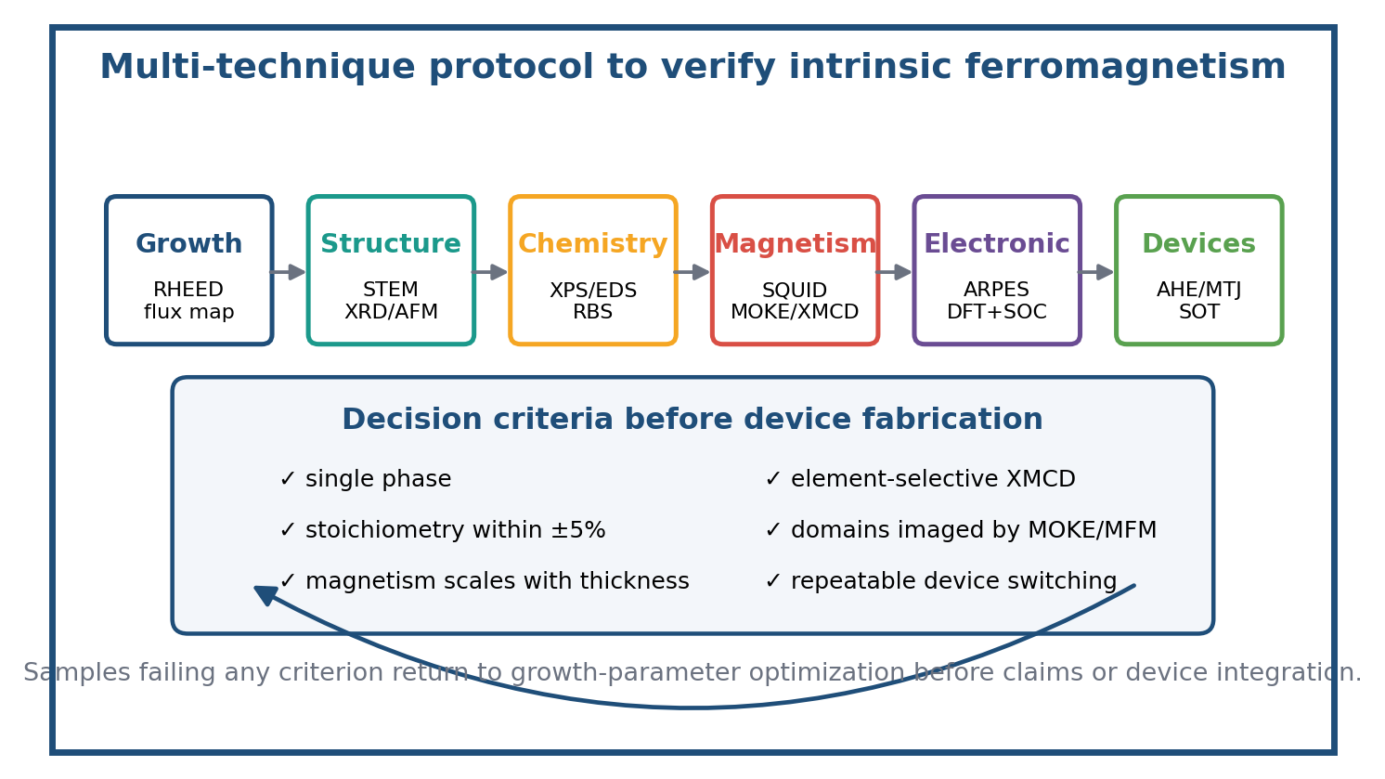
Figure 4: Characterization workflow designed to prevent false-positive assignment of intrinsic ferromagnetism. Each candidate material must pass structural, chemical, magnetic, electronic, and device-level checks before being used for mechanism or device claims.
E. Electronic structure and mechanism
ARPES will map spin-split bands, Fermi surface topology, and thickness-dependent electronic structure. DFT calculations using PBE+U and spin-orbit coupling will estimate exchange constants, magnetic anisotropy energy, defect formation energy, and strain dependence. The goal is to translate spectroscopy and theory into practical growth rules: which stoichiometry, defect density, strain state, and interface combination maximizes Curie temperature and perpendicular magnetic anisotropy without compromising device quality.
F. Device fabrication and measurement
Three device classes will be fabricated. First, Hall bar devices will quantify anomalous Hall effect, coercivity, and temperature stability. Second, magnetic tunnel junctions will use h-BN or MoS₂ tunnel barriers to evaluate tunneling magnetoresistance at 300 K. Third, spin-orbit torque devices will integrate topological insulator or heavy spin-orbit layers with 2D ferromagnets to evaluate current-induced switching, write current density, endurance, and retention.
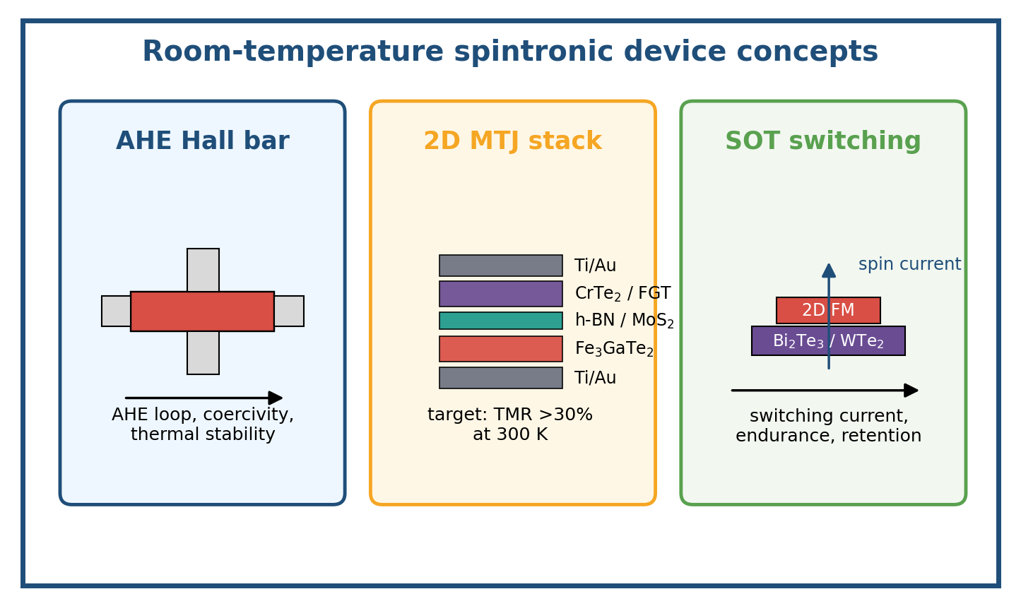
Figure 5: Device architectures for room-temperature evaluation. Hall bars establish magnetic transport, MTJs test nonvolatile memory potential, and SOT heterostructures evaluate low-power switching with topological or strong-SOC spin-current layers.
V. Work Plan, Milestones, and Timeline
The three-year work plan is organized to deliver publishable results at each stage while keeping the project resilient to materials risks. Growth studies begin immediately for CrTe₂ and Fe₃GaTe₂ because their literature baselines are strongest. MnS₂/ReS₂ and MBene tasks run in parallel as higher-risk/high-payoff routes. Device integration begins once intrinsic ferromagnetism has been validated by at least two independent magnetic probes.
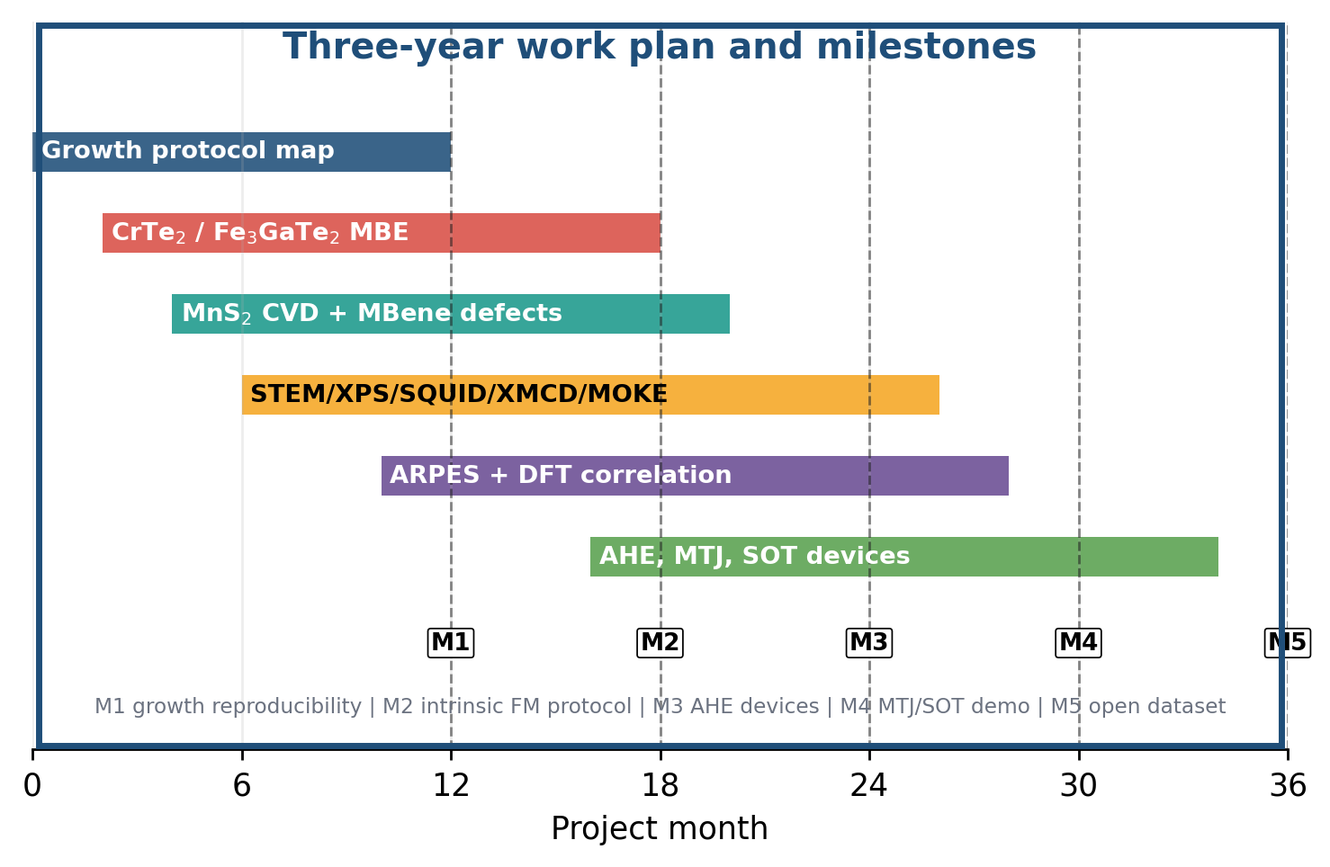
Figure 6: Project timeline. The work plan overlaps synthesis, characterization, theory, and devices to shorten the feedback loop and ensure that negative growth outcomes are converted quickly into revised growth conditions.
Period | Focus | Deliverables | Decision gate
Months 1-6 | Set up growth calibration | Flux maps, substrate cleaning protocols, first CrTe₂/Fe₃GaTe₂ films | RHEED + XPS confirm phase and stoichiometry
Months 7-12 | Magnetic verification | SQUID/MOKE/MFM data for first candidates | T_C and coercivity reproducible across growth runs
Months 13-18 | CVD and MBene expansion | MnS₂/ReS₂ and Mo₄/₃B₂ defect-series samples | Magnetic signal scales with active material, not impurity level
Months 19-24 | AHE and MTJ devices | Hall bars and preliminary tunnel stacks | Switching observed in ≥10 devices at 300 K
Months 25-30 | SOT heterostructures | 2D FM/TI devices and current switching data | Switching current density benchmarked
Months 31-36 | Integration and dissemination | Open dataset, protocol document, high-impact manuscripts | Complete reproducibility package and final report
VI. Innovation and Expected Impact
Innovation
- A complete synthesis-to-device workflow for room-temperature 2D ferromagnets rather than a single-material study.
- A rigorous intrinsic-ferromagnetism verification protocol that combines thickness dependence, element-specific magnetism, domain imaging, chemical analysis, and transport.
- Integration of semiconducting MnS₂/ReS₂ and vacancy-engineered MBenes with metallic vdW magnets to compare fundamentally different routes to room-temperature order.
- Direct feedback between DFT, ARPES, magnetometry, and growth process windows to establish predictive growth-property relationships.
Expected outputs
- Reproducible MBE/CVD recipes for high-quality 2D ferromagnetic films and heterostructures.
- A public protocol for distinguishing intrinsic ferromagnetism from contamination, substrate artifacts, and uncontrolled defects in ultrathin films.
- At least three manuscripts: growth/characterization, mechanism/theory, and device demonstration.
- Open datasets containing RHEED videos, growth logs, STEM images, magnetometry loops, ARPES maps, and device transport curves.
- Training of graduate students and postdoctoral researchers in advanced 2D materials growth, synchrotron spectroscopy, magnetic imaging, and nanofabrication.
VII. Risk Mitigation and Alternative Strategies
Risk | Impact | Mitigation / alternative route
Secondary phases or oxidation mimic magnetism | False-positive magnetic claims | Use in-situ transfer, XPS/RBS, blank-substrate controls, XMCD, and thickness scaling before device fabrication
MBE films not continuous over target area | Device yield too low | Switch to smaller proof-of-concept devices while optimizing flux/temperature; use graphene/SiC and HOPG as parallel substrates
MnS₂ phase unstable outside ReS₂ matrix | Loss of semiconducting magnetic route | Test alloyed Mn(S,Se)₂ and substrate strain; keep CrTe₂/Fe₃GaTe₂ as benchmark path
MTJ barriers have pinholes or low TMR | Memory device performance below target | Use thicker h-BN/MoS₂ barriers, deterministic dry transfer, and conductive AFM pre-screening
SOT switching current too high | Low-power goal not met | Test Bi₂Te₃, WTe₂, PtTe₂, and heavy-metal control layers; optimize interface cleanliness and FM thickness
VIII. Working Conditions and Preliminary Basis
The project requires integrated synthesis, nanofabrication, magnetic characterization, and theory. The ideal working environment includes MBE and CVD systems, glovebox or vacuum-transfer capability, cleanroom lithography, access to STEM/AFM/XPS/XRD/RBS, and magnetic probes such as SQUID, MOKE, MFM, and XMCD. Synchrotron ARPES and XMCD access should be scheduled early because these measurements are decisive for validating electronic structure and element-selective magnetism.
The current proposal should be customized with the PI group’s facilities, publication record, and preliminary data. Suggested inserts include: preliminary RHEED patterns, initial SQUID or MOKE loops, STEM images showing film continuity, device optical micrographs, and a short publication list showing prior experience in 2D materials growth, magnetic characterization, or spintronic devices.
- Recommended preliminary Figure A: RHEED evolution during Fe₃GaTe₂ growth on graphene/SiC.
- Recommended preliminary Figure B: SQUID or MOKE hysteresis loop at 300 K for the most promising pilot sample.
- Recommended preliminary Figure C: Optical or SEM image of a Hall bar or MTJ device layout fabricated from a 2D ferromagnet film.
IX. Data Management Plan
All raw and processed data will be stored in a version-controlled institutional repository. Each sample will receive a persistent identifier linking growth logs, substrate history, characterization files, device process parameters, and analysis scripts. Raw RHEED videos, XPS spectra, STEM images, SQUID loops, MOKE maps, XMCD spectra, ARPES data, and transport curves will be deposited in an open repository upon publication, with metadata sufficient for independent reuse. Analysis scripts will be released under an open-source license where allowed by institutional policy.
X. Selected References
1. Gong, C. et al. Discovery of intrinsic ferromagnetism in two-dimensional van der Waals crystals. Nature 546, 265-269 (2017).
2. Huang, B. et al. Layer-dependent ferromagnetism in a van der Waals crystal down to the monolayer limit. Nature 546, 270-273 (2017).
3. Burch, K. S., Mandrus, D. & Park, J.-G. Magnetism in two-dimensional van der Waals materials. Nature 563, 47-52 (2018).
4. Deng, Y. et al. Gate-tunable room-temperature ferromagnetism in two-dimensional Fe3GeTe2. Nature 563, 94-99 (2018).
5. Zhang, X. et al. Room-temperature intrinsic ferromagnetism in epitaxial CrTe2 ultrathin films. Nature Communications 12, 2492 (2021).
6. Zhang, G. et al. Above-room-temperature strong intrinsic ferromagnetism in 2D van der Waals Fe3GaTe2 with large perpendicular magnetic anisotropy. Nature Communications 13, 5067 (2022).
7. Wang, H. et al. Room temperature energy-efficient spin-orbit torque switching in two-dimensional van der Waals Fe3GeTe2 induced by topological insulators. Nature Communications 14, 5173 (2023).
8. Zhang, H. et al. Room-temperature ferromagnetism in epitaxial bilayer FeSb/SrTiO3(001) terminated with a Kagome lattice. Nano Letters 24, 122-129 (2024).
9. Wu, S. et al. Robust ferromagnetism in wafer-scale Fe3GaTe2 above room temperature. Nature Communications (2024).
10. Lv, H. et al. Large-area synthesis of ferromagnetic Fe5-xGeTe2/graphene van der Waals heterostructures with Curie temperature above room temperature. arXiv:2303.10252 (2023).
11. Zhang, L. et al. Vacancies engineering in molybdenum boride MBene nanosheets to activate room-temperature ferromagnetism. Advanced Materials 37, 2411765 (2025).
12. Zhao, Y. et al. Experimental evidence of room-temperature ferromagnetism in semiconducting MnS2. Journal of the American Chemical Society 147, 31212-31220 (2025).
13. Xu, J., Phelan, W. A. & Chien, C.-L. Large anomalous Nernst effect in a van der Waals ferromagnet Fe3GeTe2. Nano Letters 19, 8250-8254 (2019).
14. Ryu, J., Lee, S., Lee, K.-J. & Park, B.-G. Current-induced spin-orbit torques for spintronic applications. Advanced Materials 32, 1907148 (2020).
15. Qi, X.-L. & Zhang, S.-C. Topological insulators and superconductors. Reviews of Modern Physics 83, 1057-1110 (2011).

